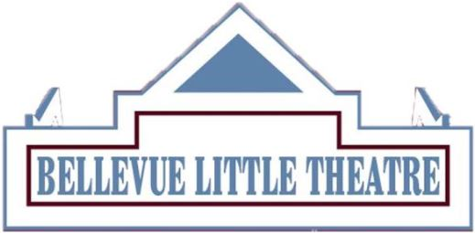
DIRECTOR QUESTIONNAIRE 2024-2025 SEASON

Name: ________________________________________________________________________

Email: ________________________________________________________________________

Last overall production in which you were involved: __________________________________

Our 2024-2025: Rating
Young Frankenstein: September 13-29, 2024 ______
It's A Wonderful Life: December 6-22, 2024 ______
The Girl on the Train: January 31- February 16, 2025 ______
The Sound of Music: March 28- April 13, 2025 ______
Ken Ludwig's Moriarty: June 6-22, 2025 ______
-With 1 being the highest & 5 being the lowest; please mark the order of the productions for which you would like to be considered. If you have equal feelings toward several shows, list them with the same number.

Thank you for your interest in the BLT—we will notify all those applying as to the decision of the Director Selection Committee.

-Please start with show title before your answer.
- If you have concerns about this show-cast size, staging problems, language, etc.-please list them.

- Do you have special needs in which the BLT needs to know about?-i.e. rehearsal times, addressing conflicts, staff suggestions, etc.

Once filled out, send in this form, a resume, two references and a letter explaining which show(s) you are interested in directing and why.
If you have directed at the BLT within the past 2 seasons,
you do not need to include a resume.
Completed questionnaires can be emailed to bellevuelittletheatre@gmail.com.

