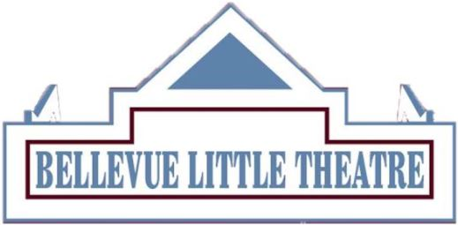
MUSIC DIRECTOR & CHOREOGRAPHER
QUESTIONNAIRE 2024-2025 SEASON

Name: ________________________________________________________________________

Email: ________________________________________________________________________

Last production in which you were involved: _________________________________________

Our 2024-2025 season: Rating
Young Frankenstein: September 13-29, 2024 ______
The Sound of Music: March 28- April 13, 2025 ______
-With 1 being the highest & 2 being the lowest; please mark the order of the productions for which you would like to be considered.

Thank you for your interest in the BLT—we will provide information to selected Directors.
Completed questionnaires can be emailed to bellevuelittletheatre@gmail.com.
Please attach a resume with this application and answer the following questions for us.

WHY DO YOU WANT TO MUSIC DIRECT THIS SHOW
-Please start with show title before your answer.
1. If you have concerns about this show-cast size, musician size, language, etc.-please list them.

2. Do you have special needs in which the BLT needs to know about?-i.e. rehearsal times, addressing conflicts, etc.

